Social Media Posts:

We are excited to announce that we are now using PaySchools Events for our upcoming events, (insert event). Save time and energy, buy your tickets today!
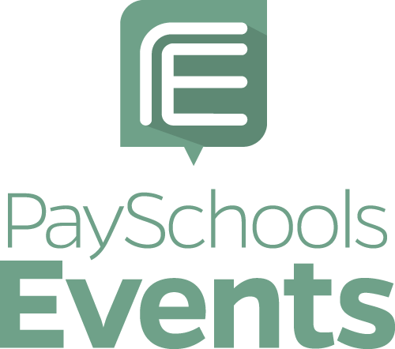

Have you purchased your (insert event name) tickets yet? Don’t miss out! For your convenience, use PaySchools Events to get your tickets today!

