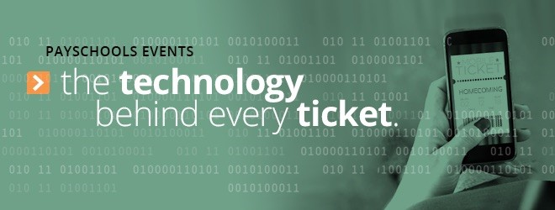

Don’t miss out on our upcoming event!

Hello,
I am reaching out regarding your student’s upcoming (Insert Event Name) Event. We are extremely excited to announce that we are now using PaySchools Events for online ticketing and purchasing ease! For your buying convenience, please purchase your tickets at (insert event link).
To make the experience as pleasant as possible, PaySchools Events has provided us with a contact for any purchasing assistance you may need, Melissa Drescher. If you have any questions regarding ticket purchasing, please contact Melissa at mdrescher@locallevelevents.com.
We look forward to seeing you at our next event!
Sincerely,
(Insert Name Here)

